*Come and join us for arts, crafts, coffee and a chat!!*

***Introducing Printmaking***

*Friday, 6th Sept, 10.30am – 12.30pm*

*CHANCE, 2, Rickaby Street, East End, Sunderland SR1 2DL*

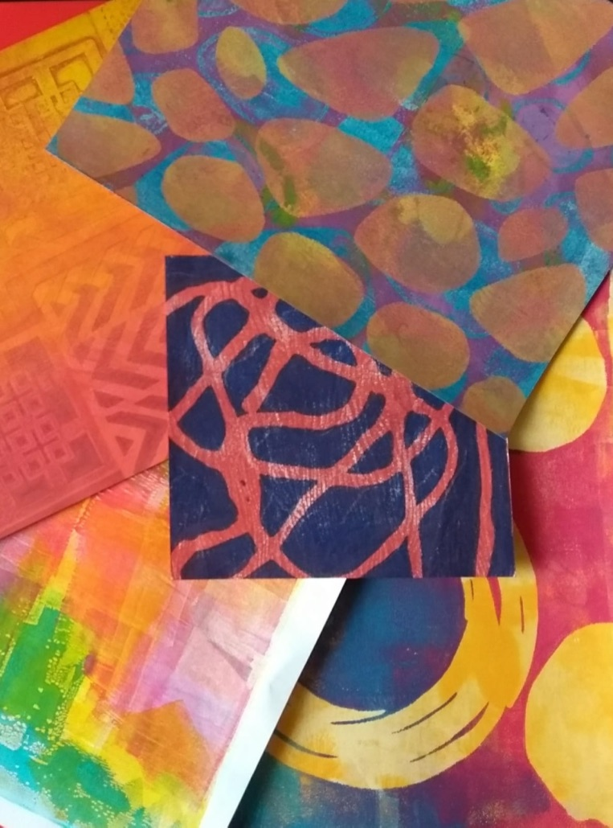

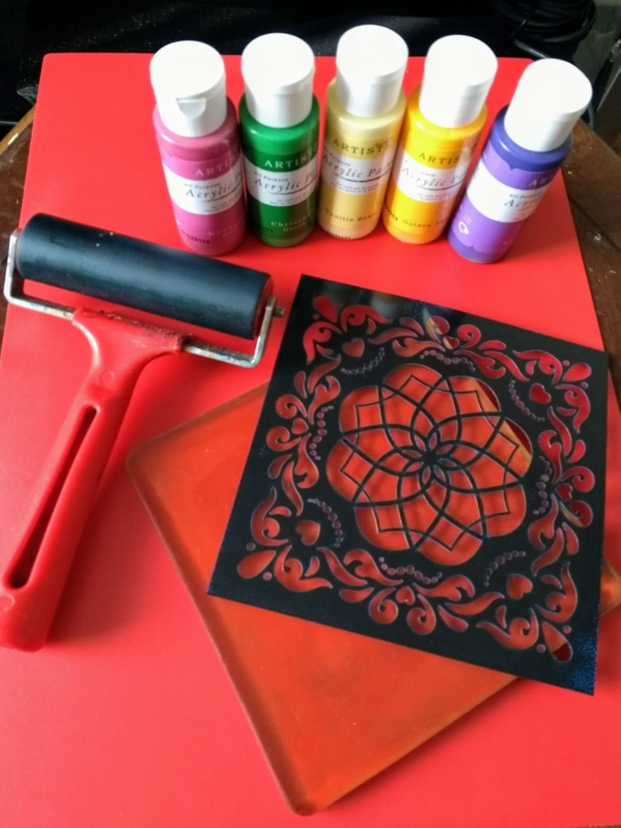

Printmaking Course - Led by Denise Lovell, the course runs over six weeks and no previous experience or artistic skill is needed. Even complete beginners can create amazing prints. Using a variety of materials, such as gel plates, stencils, texture tools and paints you will explore a world of design, patterns and creative ideas. So, don’t miss it.

Fee: £3 per session charged towards coffee and materials.

**Sunderland Women’s Art Group (SWAG)** is a friendly women’s group thatmeets every Friday at CHANCE, Sunderland helping women to feel positive about themselves through creative activities.

*For more information about the art workshops, contact Padma Rao – 07885982436*

For information about **The Well** Project – Nina Sumby – 07837639081 or *email:* [*projectsangini@gmail.com*](mailto:projectsangini@gmail.com)

*The SWAG art workshops and courses are part of* ***The Well*** *project, supported by the COUNTY DURHAM COMMUNITY FOUNDATION from the Tampon Tax Community Fund, The Community Foundation, the Foyle Foundation and Awards for All.*